|  |
| --- |
| Circle Language Spec: Globality |

## Globality

### Concept

A globality is like a little world in which objects and commands live. A globality can be a site, a computer program, a library or other kind of module. A globality groups together functionality or data.

A globality is an object with a special property. Anything directly inside the globality can be directly referenced from anywhere within the globality. That is the basic principle. However, you don’t have to make everything directly inside the globality accessible globally; you have to actively declare them as being globally accessible. If members of a globality are just publically accessible, they are not globally accessible, they are just accessible as members of an object, and not accessible from anywhere within the globality. It’s also not entirely true, that everything inside the globality can access the global members. You can only access global member from members, whose fixed logical residence is inside the globality. So global things can only be directly accessed from definitions, whose fixed logical residence is inside the globality. Things *referenced* inside the globality, whose definition is elsewhere, can not access the global members.

You can reference a globality like referencing an object. In that case it behaves like a normal object reference.

You can also reference a globality directly from within another globality. In that case, one globality has a reference to another: one module has a reference to another module. Everything of the referenced module is now globally accessible from anywhere within the other module.

You don’t need to let globalities refer to eachother, to actually let one module use something from another module: one module can always access anything inside another module, whether it has a reference to it or not. A reference however, makes global things from one module, globally accessible inside another module.

### In a Diagram

The principle of globality is explained in the article *Globality*. This article demonstrates its expression in a diagram.

A globality is displayed as a pentagon shape



Objects and commands can be placed inside the pentagon.

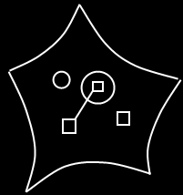

Access to global members happens in the diagram in the following way.

Definitions anywhere within the globality can access anything declared global. To make reference lines to global members more overviewable, imaginary intermediate references to the globality are added to all the mutual parents from which global things are accessed. See the article *Automatic Containment* for information about imaginary references and mutual parents.

The globality itself might not be in sight, when you are zoomed in on *part* of the globality. The solution is, that an imaginary reference to the globality is always displayed at the highest visible level of containment.

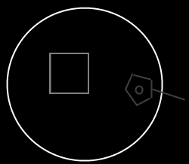

The imaginary reference to the globality displays all the global members of the globality. You can point to the global things you see inside this imaginary reference.

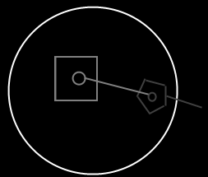

The imaginary references to globality are displayed as pentagons, that’s how you recognize it is global things you are accessing.

Here is a globality with a reference to another globality:

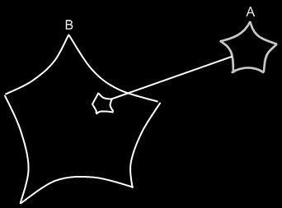

This makes all the global members of module A, globally accessible from inside module B.

## Ideas

*The texts below are ideas yet to be turned into good documentation.*

### Out of the original Symbol documentation

#### Multiple Globality Levels

A globality B inside a globality A is accessible by A. A globality C inside globality B is not accessible by A unless declared public.

globality A outside globality B can not be accessed by B.

What about ‘system wide’ things that can be accessed from anywhere? It can be reached from embedded globalities, which disobeys the rule just defined. If it’s really system wide, then you simply embed a globality by linking to the shared instance of a module.

But what if it’s less system wide? In that case it seems that a deep globality has access to a shallower globality… << I’ll figure out later >>

If a globality is declared public, it becomes a sub module in the Sigma module.

Global is a bad term.

Because global insinuates its scope is the entire earth.

That’s why I call it a *globality*. That implies there can be multiple globalities. But still it might be a bad term, because it’s not really global (the entire earth). But then again: a globality was defined as ‘a little world in which objects live’. So then it is a good term again.

2004,

A pentagon's direct children can all reference eachother and can be

referenced by all ancestors (containmentwise ancestors). Globality is

only one function of a pentagon. Actually a pentagon is a lot like

globality, where there are multiple levels of globality and that exists in today's systems.

JJ

#### System Procedures for Globalities

System procedures of globalities are the same as for other object symbols. The only restriction is that globalities can’t have lines to objects and objects can’t have lines to globalities. Globalities can have an object line, type line and interface line just like objects.